Models & routes
models/Student.js
routes/students.js

Prepared by : Mathuppriya Naguleswaran

Student.js
This file defines the structure of student data in MongoDB.
Student model includes: Name, email, faculty, year
Model : MongoDB is schema-less (NoSQL).
- You can store anything
- But that’s dangerous

without model:
{ "name": 12345 }
{ "email": true }
- Wrong data
- No control
- Messy database
So we use Mongoose Model
Model = rules for your data
- correct types
- required fields
- validation
- consistency

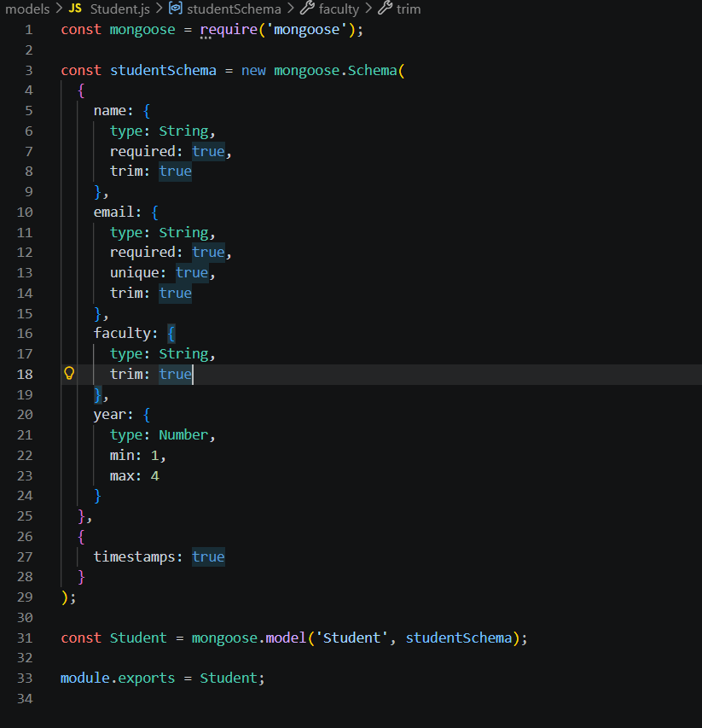

- Import mongoose
const mongoose = require('mongoose');

- We need Mongoose to: define schema, create model, interact with MongoDB.
- Without this: cannot define database structure
- Create Schema
const studentSchema = new mongoose.Schema(...)

Schema = blueprint of data
Like: form structure, database rules, data design
Schema is like a form template:
Field | Type
name | Text
Email | Text
year | number

- Field-by-Field Deep Explanation
- name field type:String = only text allowed => { "name": 123 } ❌ Invalid
name: {
type: String,
required: true,
trim: true
}
required: true = must provide this field
trim: true = Removes extra spaces => " John " → "John"
Without trim: duplicate data possible, messy database
Example: "John" , " John " , "John " All treated as different

- email field
unique: true = no duplicate emails allowed (Because: email identifies a user, prevents duplicates.
email: {
type: String,
required: true,
unique: true,
trim: true
}

unique is NOT validation
It creates a database index So, MongoDB enforces uniqueness error occurs if duplicate

- faculty field
faculty: {
type: String,
trim: true
}
trim : clean data , avoid spaces

- year field
year: {
type: Number,
min: 1,
max: 4
}

type: Number = Only numeric values allowed
min: 1 = Minimum allowed value = 1
max: 4 = Maximum allowed value = 4
This is called validation rule.

- Schema Options
{
timestamps: true
}
Automatically adds: createdAt , updatedAt
WHY
- track record creation
- track updates
- useful for analytics

- Create Model
const Student = mongoose.model('Student', studentSchema);
Think like this:
Schema = Rules
Model = Tool to use rules

Model = interface to interact with database
With Model you can:
- Student.create()
- Student.find()
- Student.findById()
- Student.delete()
- Export Model
module.exports = Student;

Why export : To use this model in other files
Example: const Student = require('../models/Student');

Full Flow with Student Model : Postman → Route → Student Model → MongoDB
Example Request
POST /students
{
"name": "Alice",
"email": "alice@gmail.com",
"year": 2
}

What happens internally:
- Route receives request
- Creates new Student
- Mongoose validates schema
- If valid → saves to MongoDB
- If invalid → error

This file defines the Student model using Mongoose, which represents how student data is stored in MongoDB. I have applied validation rules such as required fields, unique email, trimming whitespace, and restricting the year between 1 and 4 to ensure data integrity. Additionally, timestamps are enabled to automatically track when each record is created and updated. In simply Student.js teaches Data modeling, Validation, Schema design, Data integrity, MongoDB structure, Clean database practices.

routes/students.js
This file defines the API endpoints related to students.
- model = what student data looks like (defined the data structure)
- route = how client can create or read that data (defines the operations users can perform on that data)

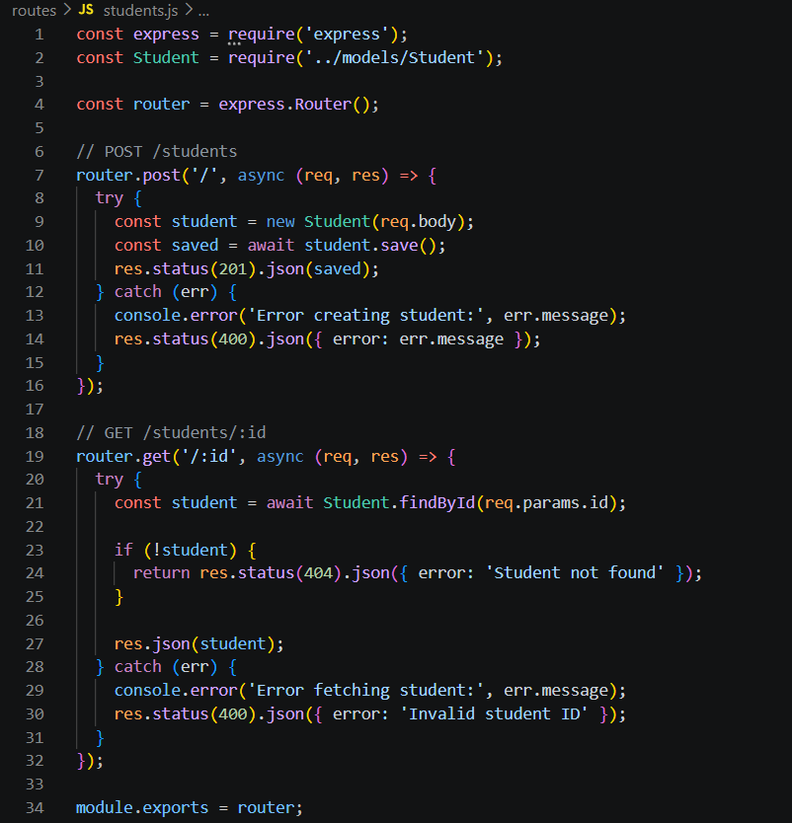
- Import Express
const express = require('express');

- Imports Express so we can use routing features.
- Why need here : Because this file creates a router object, and router comes from Express.

- Import Student model
const Student = require('../models/Student');

- Imports the Student model from the models folder.
- Because routes need to interact with the database.
- route file does not store data by itself.
It uses the model to:
- create student
- find student by ID

- ../models/Student
- this file is inside routes/
- .. = go one level up
- then go into models/
- then open Student.js

3. Create router
const router = express.Router();

- Creates a new router object.
- A router is like a mini Express app used to group related routes.
- Because app is used in server.js for the whole application, while router is used inside feature files. This keeps routes modular.
Think of it like
- app = main server
- router = department for one feature

4. Define POST route
router.post('/', async (req, res) => {

- Defines a POST endpoint.
- Why '/' and not '/students'? : Because in server.js, this router is mounted like:
app.use('/students', studentRoutes);
- So the base path is already /students.
- That means:
- router.post('/') becomes POST /students
- This is a very important routing concept.
- POST is used to create new data.
- So here, the client sends student details, and the server stores a new student record.
- Async : Because saving to database takes time, and database operations are asynchronous. Without async, you cannot use await.

  - Start try block try {
Why we use try : Because database operations can fail. (Possible reasons: missing required field, duplicate email, wrong type, database problem
A backend should handle errors safely instead of crashing.

  - Create new student object
const student = new Student(req.body);

Creates a new Student document using the request body.
req.body : It contains JSON sent by the client.
Example request body:
{
"name": "Alice",
"email": "alice@example.com",
"faculty": "Computing",
"year": 2
}

Mongoose prepares a new student document based on schema rules. It does not save yet. It only creates an in-memory object. Why this is powerful : Because the Student model already knows: field names, types, validation rules. So route code stays simple.

  - Save to database
const student = new Student(req.body);

Saves the student document into MongoDB.
Await : Because saving is asynchronous and takes time. The code waits until MongoDB confirms the save.
.save() : Mongoose:
- validates data against schema
- sends insert request to MongoDB
- gets saved document back
What can fail here : required field missing, duplicate email, invalid year, connection issue. That is why .save() is inside try.

8. Send success response
res.status(201).json(saved);

Sends the saved student back to the client as JSON.
  - = HTTP status code 201 Created (a new resource was created successfully )
This is better than 200 for create operations.
Why return saved data : Because client may need: generated _id, timestamps, confirmed stored values
{
"_id": "661234...",
"name": "Alice",
"email": "alice@example.com",
"faculty": "Computing",
"year": 2,
"createdAt": "...",
"updatedAt": "..."
}
Example response: =>

9. Catch errors
} catch (err) {

Runs if any error happens inside the try block.

10. Log error message
console.error('Error creating student:', err.message);

Why : Because developers need to see what went wrong in the terminal.
This helps debugging.
err.message : Because it gives the useful part of the error in a readable format.

11. Send error response
res.status(400).json({ error: err.message });

- : Status 400 Bad Request means the client sent invalid data.(duplicate email, missing required field, invalid year )
Why return JSON error : Because API clients need structured error messages.
{
"error": "Student validation failed: name: Path `name` is required."
}

Example:

12. Define GET route
router.get('/:id', async (req, res) => {

Defines a GET endpoint with a route parameter.
:id = It is a dynamic parameter.
If client requests: GET /students/661234abcd
then: req.params.id
will contain: 661234abcd

GET is used to retrieve data.

13. Find student by ID
const student = await Student.findById(req.params.id);

Searches MongoDB for a student with the given _id.
findById : Because MongoDB automatically gives every document a unique _id.
This is the fastest and simplest way to fetch one record by ID.
Await : Because querying database is asynchronous.

14. Check if not found
if (!student) {
return res.status(404).json({ error: 'Student not found' });
}

If the ID format is valid but no student exists with that ID, findById() returns null.
404 : Status 404 Not Found means:
- request was valid but resource does not exist
return : Because once we send the response, function should stop.
Without return, code may continue and try to send another response.

15. Send found student
res.json(student);

Returns the student document as JSON.
Why no explicit status code : Because Express uses 200 OK by default for successful responses.
That is correct for a successful GET request.

16. Catch invalid ID errors
} catch (err) {
console.error('Error fetching student:', err.message);
res.status(400).json({ error: 'Invalid student ID' });
}

If the ID format itself is invalid, Mongoose may throw an error.
Example invalid ID: abc = This is not a valid MongoDB ObjectId.

400 : Because the client sent a bad parameter format.
Difference between 400 and 404
400 = ID format is invalid
404 = ID format is valid, but record not found
This is a very important backend distinction.

17. Export router
module.exports = router;

Exports the router so server.js can import it.
Without exporting, server.js cannot mount these routes.

Full request flow for POST /students
{
"name": "Alice",
"email": "alice@example.com",
"faculty": "Computing",
"year": 2
}

Let’s say Postman sends:

Flow:
- Request goes to POST /students
- server.js forwards it to students.js
- router.post('/') runs
- new Student(req.body) creates a document
- .save() validates and stores it
- Response 201 + saved JSON returns

Full request flow for GET /students/:id
Example: GET /students/661234abcd5678...
Flow:
- Request goes to GET /students/:id
- Router reads req.params.id
- Student.findById() searches database
- If found, returns student JSON
- If not found, returns 404
- If invalid ID format, returns 400

This file handles the student-related API routes in the backend (students.js file defines the student-related API endpoints using Express Router). It allows us to create a new student record with POST /students and retrieve an existing student by its unique ID using GET /students/:id while interacting with the Student model for database operations. I also included error handling for invalid input, duplicate or missing data, and not-found cases to make the API more reliable. Proper error handling is included to manage validation failures, invalid IDs, and missing records using suitable HTTP status codes.

models | routes
defined the data structure | defines the operations users can perform on that data
Import mongoose | Import express

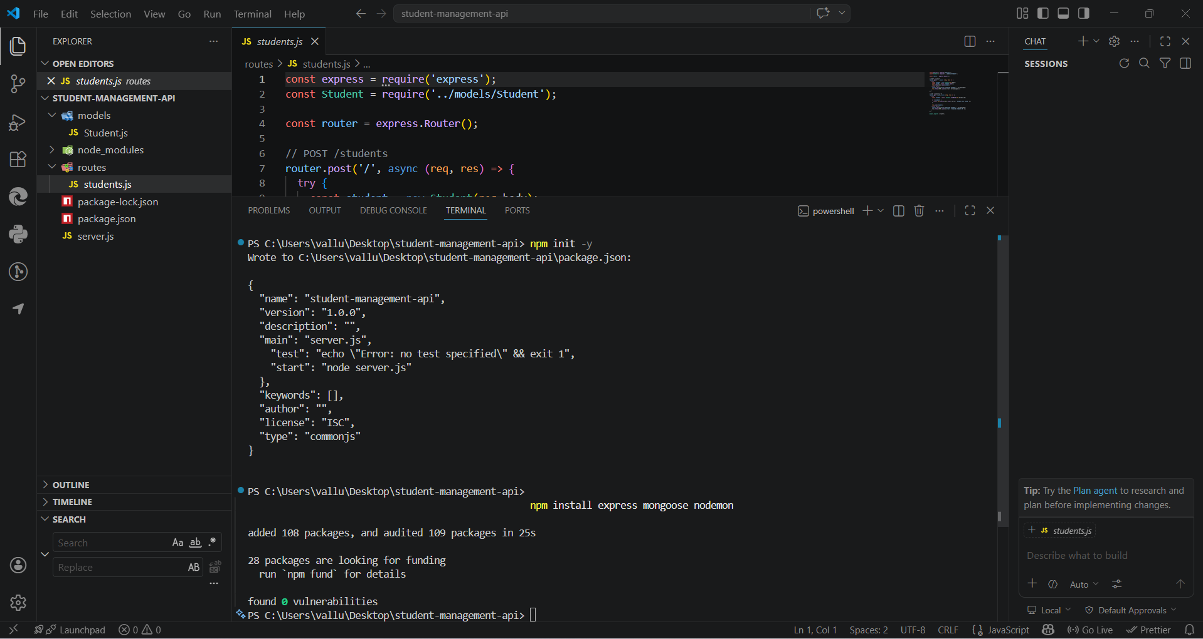
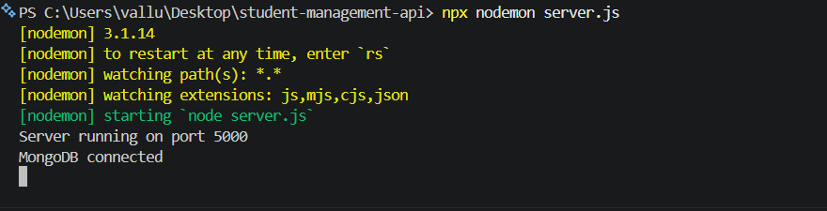

If you run your server like this: node server.js
It works… BUT When you change code:
- Server does NOT update
- You must manually stop + restart every time
- You must press: Ctrl + C , then node server.js

nodemon = auto-restart tool
What it does: To automatically restart the server when code changes
- Watches your files
- Detects changes
- Automatically restarts server
- Improves development speed
- Avoids manual restart
npx = runs packages without global install
So: npx nodemon server.js means: “Run nodemon (even if not installed globally)”

When do we use nodemon : During development only NOT used in production

node = manual
nodemon = automatic
You can add this in package.json:
"scripts": {
"dev": "nodemon server.js"
}
Then run: npm run dev

